DEPARTMENT OF COMPUTER SCIENCE AND ENGINEERING
ASSIGNMENT REPORT
Design and Deployment of a Cloud-Based Virtualized
Collaboration Platform for an Engineering College

Course Details | Information
Course Code & Name | CSA15 – Cloud Computing and Big Data Analytics
Assignment Title | Design and Deployment of a Cloud-Based Virtualized Collaboration Platform for an Engineering College
Course Outcomes | CO1, CO2, CO3
Bloom’s Taxonomy | L3 – Apply; L4 – Analyse
SDG Mapping | SDG 4 – Quality Education; SDG 8 – Decent Work and Economic Growth; SDG 9 – Industry, Innovation and Infrastructure

Prepared by: K.Divya
Register No.: 192511316

Executive Summary
This report proposes a cloud-based virtualized infrastructure for a small engineering college that currently operates separate physical systems for application hosting, file storage, and user access. The design maps institutional requirements to Infrastructure as a Service (IaaS), Platform as a Service (PaaS), and Software as a Service (SaaS), and then translates those requirements into a small virtualized data-center environment. The proposed environment uses multiple virtual machines (VMs), a controlled virtual network, secure remote access, role-based permissions, and cloud collaboration services.
The report is deliberately structured around the assessment rubric. It covers requirement identification, service-model analysis, virtualized data-center architecture, VM resource allocation, network and service communication, secure remote access, user roles and permissions, security controls, comparison with traditional infrastructure, limitations, reflection, and the required evidence/GitHub deliverables.

Assessment Coverage Matrix
Rubric Criterion | Max | Where Addressed in This Report
Cloud Service Model – Identification & Requirement Analysis (CO1) | 15 | Chapters 2–3
Cloud Service Model – Analysis (CO1) | 15 | Chapter 4
Virtualized Data Center Architecture (CO2) | 15 | Chapter 5
Virtual Machine Deployment & Resource Configuration (CO2) | 15 | Chapter 6
Network Configuration & Service Communication (CO2) | 10 | Chapter 7
Cloud Access & Remote Resource Management (CO3) | 10 | Chapter 8
User Roles, Permissions & Security (CO3) | 10 | Chapter 9
Analysis, Comparison & Reflection (CO1/CO2/CO3) | 10 | Chapter 10
Deliverables | — | Chapter 11 + Appendices

1. Problem Statement and Objectives

1.1 Problem Statement
A small educational institution plans to migrate its existing IT infrastructure to a cloud-based environment to support online learning, file sharing, application hosting, and collaborative academic activities. The current environment maintains separate physical systems for application hosting, file storage, and user access. This causes high infrastructure costs, inefficient resource utilization, and difficulty in managing resources during high-demand periods.
The proposed solution must demonstrate different cloud service models, virtualization, cloud access mechanisms, and collaborative services. A small virtualized data-center environment is therefore designed with multiple VMs representing different infrastructure services.

1.2 Objectives
- Identify institutional computing, storage, learning, collaboration, security, and access requirements.
- Map requirements to appropriate IaaS, PaaS, and SaaS service models with justification.
- Design a small virtualized data-center architecture with clearly defined VMs, services, resources, and connectivity.
- Deploy and configure multiple VMs using a suitable virtualization platform such as VirtualBox or VMware.
- Configure a virtual network so that the deployed services can communicate reliably.
- Demonstrate secure remote access and remote resource management.
- Define user roles and permissions and apply basic resource-protection controls.
- Configure collaboration services for document sharing, file access, communication, and collaborative editing.
- Compare the proposed cloud environment with traditional physical infrastructure.
- Document implementation evidence and prepare a GitHub repository containing the project artifacts.

1.3 Scope
- Small educational institution / engineering-college scenario.
- Four logical VMs: Web/Application, File/Collaboration, Database, and Monitoring/Backup.
- Virtual network using NAT plus Host-only or Bridged networking as required.
- Secure administrative access using SSH and secure web access using HTTPS where supported.
- Role-based access for administrator, faculty, student, and support/IT users.
- Cloud collaboration layer for document sharing, communication, and collaborative editing.
- Evidence-based implementation: actual screenshots must be inserted in the marked evidence slots after deployment.

2. Institutional Requirement Analysis

2.1 Functional Requirements
Requirement | Description | Priority | Cloud/Virtualization Need
Online learning | Access learning applications and academic resources remotely. | High | Scalable application hosting and secure access
File sharing | Store, upload, download, and share academic files. | High | Centralized cloud file service
Collaborative editing | Multiple users work on academic documents. | High | SaaS collaboration platform
Application hosting | Host institutional web/application services. | High | IaaS VM or PaaS deployment
Database service | Store application and academic metadata. | High | Dedicated VM or managed database
User access | Students and staff require controlled remote access. | High | Identity, roles, authentication
Communication | Support academic communication and coordination. | Medium | Cloud collaboration/communication tools
Backup and monitoring | Protect data and monitor resource usage. | High | Backup/monitoring VM and policies

2.2 Non-Functional Requirements
- Scalability: resources should be expandable during examination, admission, or assignment-submission peaks.
- Availability: important academic services should remain accessible with planned backup and recovery.
- Performance: CPU, RAM, storage, and network resources should be allocated according to service needs.
- Security: authentication, least-privilege permissions, secure protocols, firewall rules, and backup protection are required.
- Accessibility: authorized users should be able to access resources from approved devices and locations.
- Cost efficiency: avoid over-provisioning and consolidate workloads using virtualization.
- Manageability: administrators should be able to monitor and manage resources remotely.
- Collaboration: users should be able to share and edit documents without maintaining separate copies.

2.3 Peak-Demand Analysis
The environment should support periods in which many students access learning content simultaneously. Virtualization allows CPU, memory, and storage allocations to be adjusted without purchasing a separate physical server for every workload. The database and application VMs receive higher priority, while monitoring and backup services can be scheduled during lower-demand periods.

3. Cloud Service Model Mapping

3.1 IaaS Mapping
IaaS provides virtualized computing infrastructure such as VMs, virtual networks, storage, and administrative control. For this institution, IaaS is appropriate when the college needs control over operating systems, server configuration, networking, and application deployment.
Institutional Need | IaaS Solution | Reason
Application hosting | Linux VM running web/application server | Full OS and server-level control
Database | Dedicated database VM | Controlled database configuration and isolation
File storage | File/collaboration VM with attached storage | Centralized storage and permissions
Monitoring/backup | Monitoring and backup VM | Central administration and recovery support
Network connectivity | Virtual switches, NAT/Host-only/Bridge | Controlled service-to-service communication

3.2 PaaS Mapping
PaaS is suitable for application development and deployment when developers need a managed runtime, database, deployment pipeline, or platform services without maintaining the underlying operating system. A college application team can use a PaaS environment for student portals, APIs, or academic applications.
- Managed application runtime for web portals and APIs.
- Managed database or application data service where available.
- Automated application deployment and scaling.
- Reduced operating-system maintenance for the development team.

3.3 SaaS Mapping
SaaS is the most suitable model for end-user collaboration because the institution can consume a complete application through a browser without managing the underlying servers. Examples include cloud document editors, file-sharing applications, institutional email, calendars, and communication platforms.
Need | SaaS Capability | Primary Users
Document sharing | Cloud drive / shared folders | Students, faculty
Collaborative editing | Browser-based document editor | Students, faculty
Communication | Chat/video/announcement platform | Students, faculty, administrators
Email/calendar | Managed productivity suite | All authorized users

4. Analysis of Cloud Service Models
Factor | IaaS | PaaS | SaaS
Main control | High; OS, network, storage | Medium; application/runtime level | Low; provider manages platform
User responsibility | VMs, OS, apps, data, configuration | Application code and data | User settings and content
Scalability | High but needs planning | High and often platform-assisted | Usually provider-managed
Accessibility | Remote through configured access | Remote through platform | Usually browser/app based
Cost pattern | Compute + storage + network | Usage/platform charges | Subscription or usage
Security responsibility | Shared; significant customer responsibility | Shared; platform reduces infrastructure burden | Mostly provider-managed with customer access controls
Best use here | Core virtualized data center | Application development/deployment | Collaboration and productivity

4.1 Cost Considerations
- Traditional model: separate physical servers create capital expenditure, power consumption, cooling requirements, and maintenance effort.
- Virtualized IaaS model: several workloads share a physical host, improving hardware utilization.
- PaaS model: reduces OS and runtime administration but may introduce platform usage costs and vendor dependency.
- SaaS model: minimizes infrastructure administration but recurring subscription cost and provider dependency should be considered.
- A hybrid approach is appropriate when the institution needs control for core workloads and managed services for collaboration.

4.2 Scalability, Accessibility and Security
IaaS provides flexible resource allocation but requires careful capacity planning. PaaS simplifies application scaling and deployment. SaaS provides the highest convenience for end users and generally the lowest infrastructure-management burden. Across all models, identity management, strong authentication, least privilege, secure network configuration, backup, and monitoring remain important.

5. Virtualized Data Center Architecture
The proposed data center consolidates multiple institutional services into virtual machines running on a common virtualization host. The architecture separates service responsibilities so that a failure or maintenance activity in one workload has less impact on other workloads.
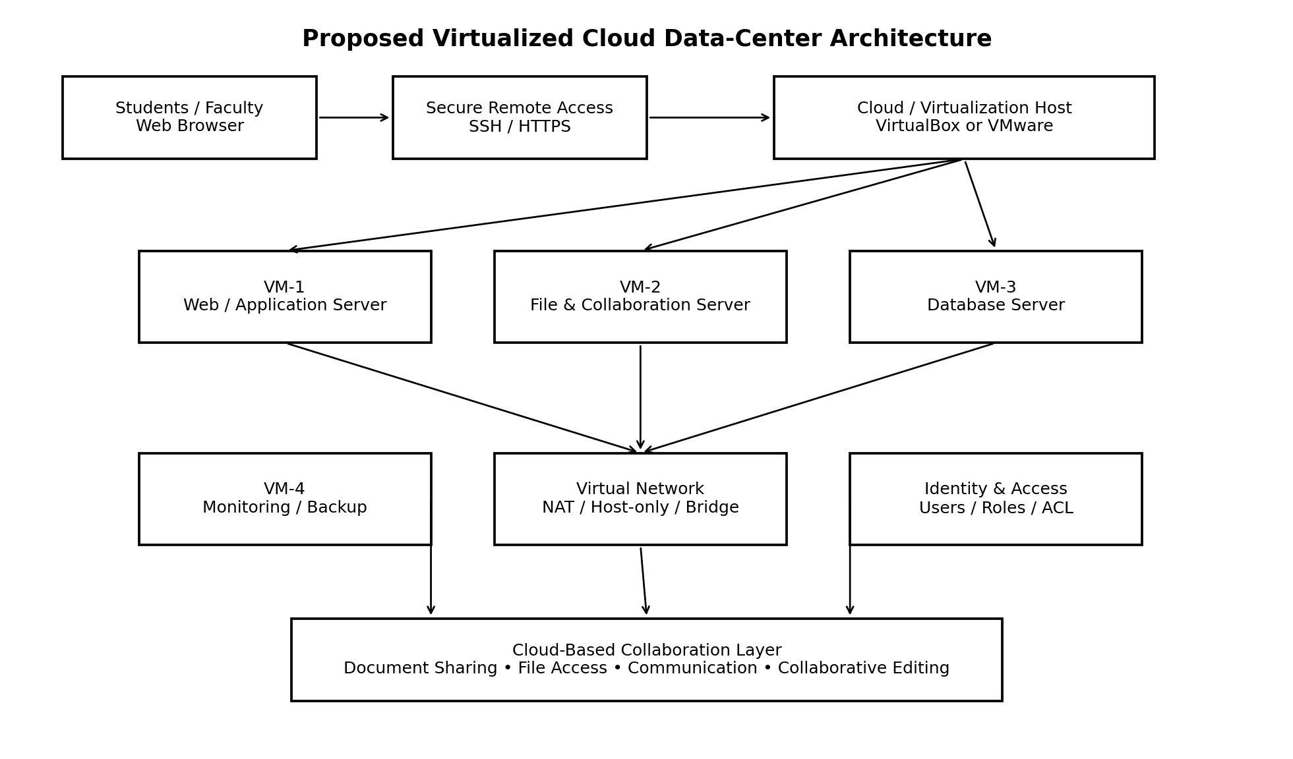
Figure 1. Proposed virtualized data-center and collaboration architecture.

5.1 VM and Service Definition
VM | Role | Suggested OS | vCPU | RAM | Storage | Main Services
VM-1 | Web/Application Server | Ubuntu Server / equivalent Linux | 2 | 2 GB | 20 GB | Web server, application/API
VM-2 | File & Collaboration Server | Ubuntu Server / equivalent Linux | 2 | 4 GB | 40 GB | File sharing, collaborative storage
VM-3 | Database Server | Ubuntu Server / equivalent Linux | 2 | 2–4 GB | 25 GB | Database service
VM-4 | Monitoring & Backup | Ubuntu Server / equivalent Linux | 1–2 | 2 GB | 30 GB | Monitoring, logs, backup repository

5.2 Host Resource Planning
The suggested allocations are intentionally small for a classroom-scale demonstration. The host machine must have sufficient RAM and storage for the hypervisor plus all VMs. Resources should be adjusted based on the actual host specification. The purpose is to demonstrate logical resource planning rather than prescribe a production sizing model.
Resource | Planning Approach | Reason
CPU | Allocate 1–2 vCPUs per VM; prioritize application/database VMs | Avoid unnecessary CPU overcommit
RAM | Allocate more RAM to collaboration and database services | These workloads may require more memory
Storage | Use separate virtual disks/partitions for data where practical | Improves organization and backup
Network | Use controlled virtual networking | Enables service communication and isolation
Backup | Keep backup data separate from primary service disks | Reduces impact of service failure

5.3 Network Topology
- NAT adapter: provides outbound internet connectivity for package updates when needed.
- Host-only adapter: provides a controlled private network for VM-to-VM and host-to-VM administration.
- Bridged adapter: optional when a VM must be reachable directly from the institutional LAN.
- Firewall rules: permit only required service ports and administrative access.
- Service communication: Web/Application VM communicates with Database VM; authorized clients communicate with the application and file services.

6. Virtual Machine Deployment and Resource Configuration

6.1 Recommended Deployment Sequence
- Install a virtualization platform such as VirtualBox or VMware Workstation on the host.
- Create a Linux server VM template with a suitable virtual disk and network adapter.
- Clone or create the required VMs and assign unique hostnames.
- Configure CPU, RAM, storage, and network interfaces according to the resource table.
- Assign static private IP addresses to server VMs on the internal network.
- Update the operating systems and install only required server packages.
- Configure the application, file/collaboration, database, and monitoring services.
- Create user accounts and apply role-based permissions.
- Configure firewall rules and secure remote administration.
- Test service-to-service communication and remote access.
- Capture screenshots of each successful configuration and test.
- Commit the configuration notes, diagrams, screenshots, and report to GitHub.

6.2 Example VM Configuration Table
VM | Hostname | Private IP Example | Gateway | Key Test
VM-1 | app-server | 192.168.56.11 | 192.168.56.1 | HTTP/HTTPS response
VM-2 | collab-server | 192.168.56.12 | 192.168.56.1 | File access / collaboration
VM-3 | db-server | 192.168.56.13 | 192.168.56.1 | Database connectivity
VM-4 | monitor-server | 192.168.56.14 | 192.168.56.1 | Monitoring/log collection

Note: The IP addresses above are example values for a host-only network. They must be changed if they conflict with the actual lab network. Do not submit example addresses as evidence unless they are the addresses actually configured.

6.3 Evidence Required for Full-Rubric Implementation
Evidence ID | Screenshot / Evidence to Capture | Rubric Supported
E1 | Virtualization platform showing all four VMs | CO2 – VM deployment
E2 | VM CPU/RAM/storage settings for at least one VM | CO2 – Resource configuration
E3 | Network adapter configuration | CO2 – Network configuration
E4 | Terminal showing hostname/IP configuration | CO2 – Deployment
E5 | Application server running | CO2 – Service implementation
E6 | File/collaboration service running | CO2/CO3 – Collaboration
E7 | Database service running and reachable | CO2 – Service communication
E8 | Ping / connectivity test between VMs | CO2 – Communication
E9 | SSH remote login from authorized client | CO3 – Secure remote access
E10 | User/role and permission configuration | CO3 – Security
E11 | Collaborative document being shared/edited | CO3 – Collaboration
E12 | GitHub repository containing project files | Deliverable 6

6.4 Screenshot Insertion Slots

The following screenshots provide implementation evidence from the developed EduCloud VDC portal. They are mapped to the corresponding rubric evidence items; actual hypervisor screenshots are still required for E1–E4 where specified.
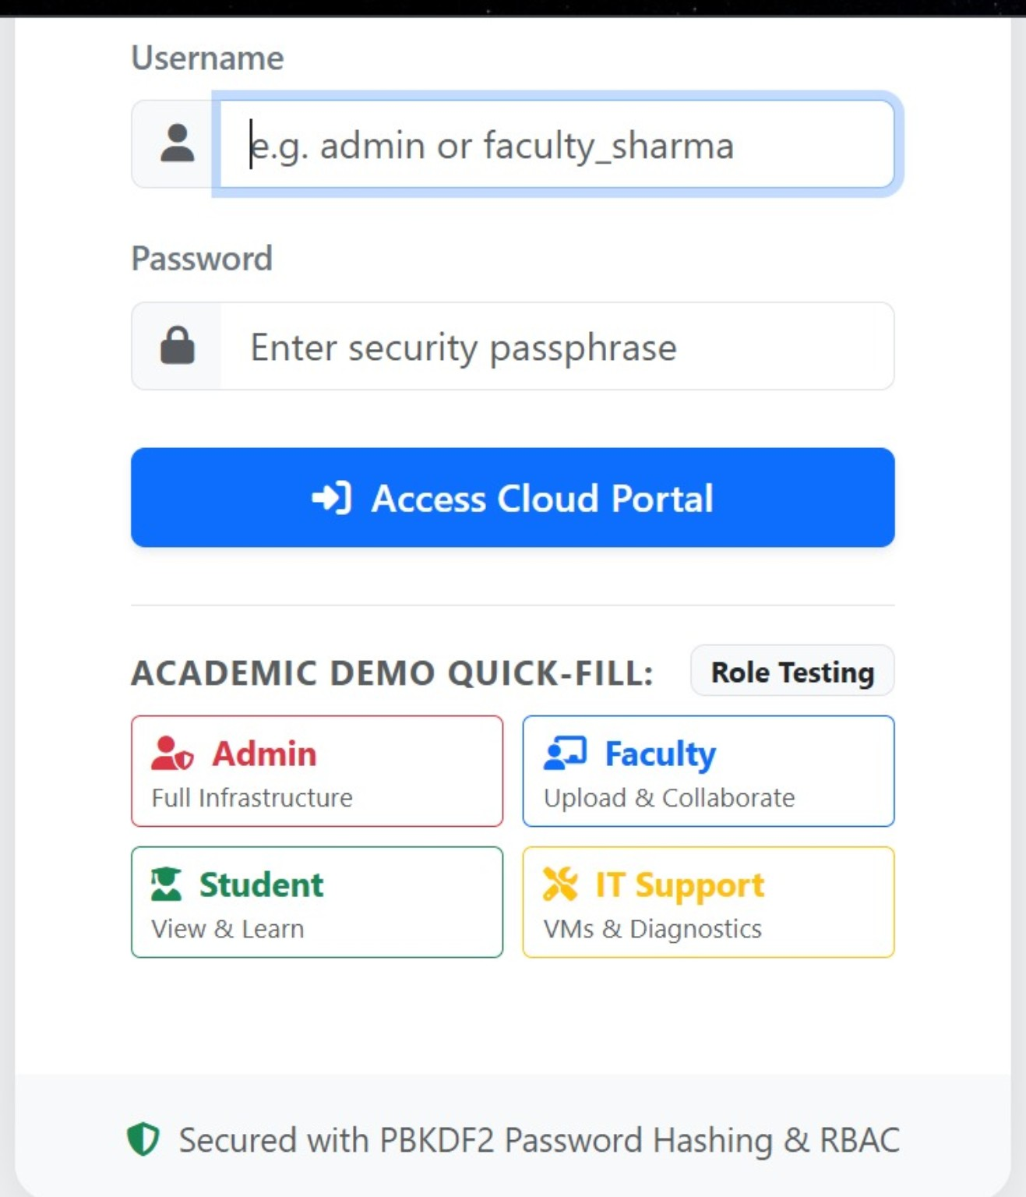
Figure 2. EduCloud VDC login and role-testing interface (supports E5 – application access evidence).
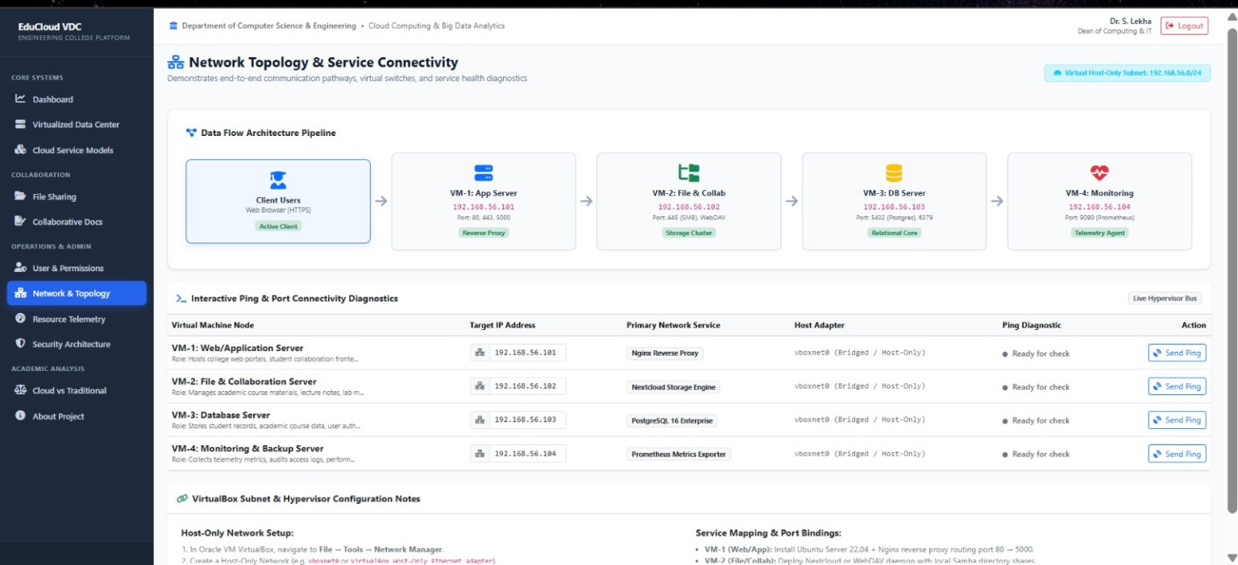
Figure 3. EduCloud VDC network topology and service connectivity dashboard (supports E8 – connectivity/service communication evidence).
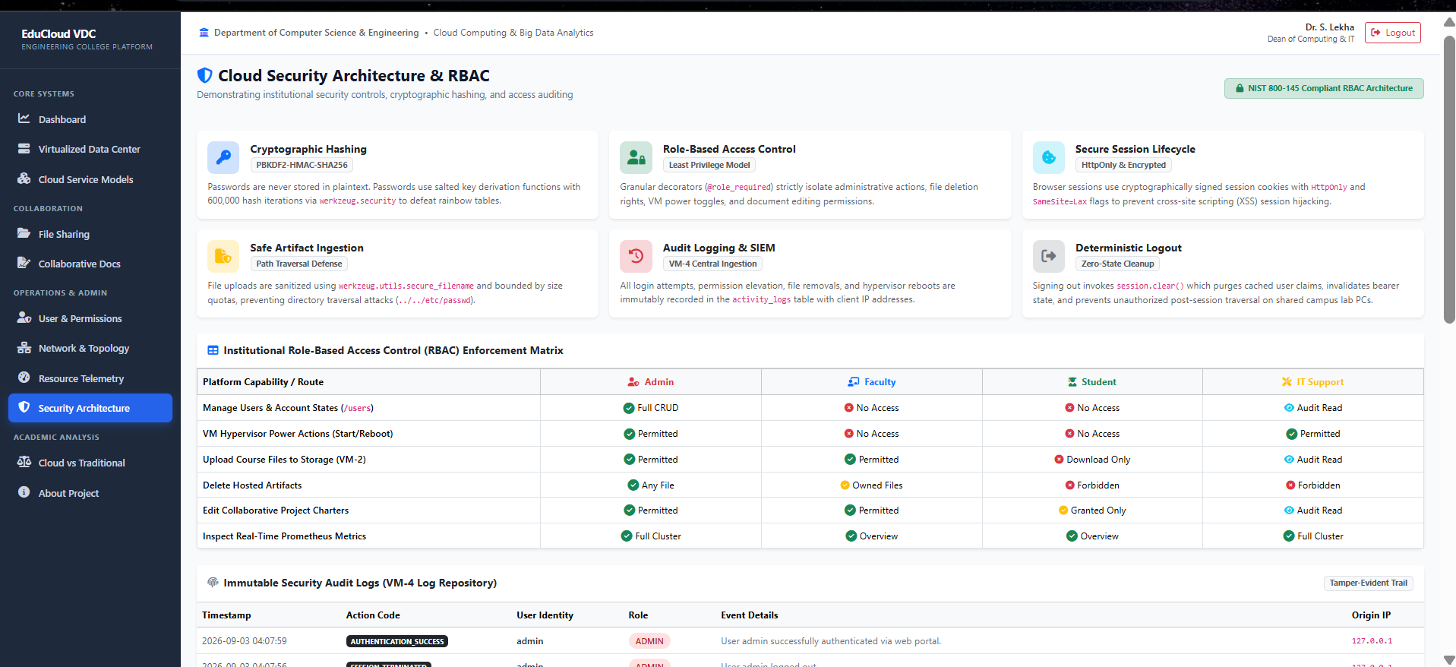
Figure 4. EduCloud VDC cloud security architecture and RBAC enforcement matrix (supports E10 – roles/permissions and security evidence).

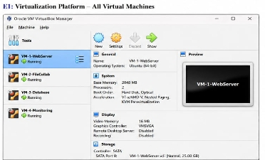
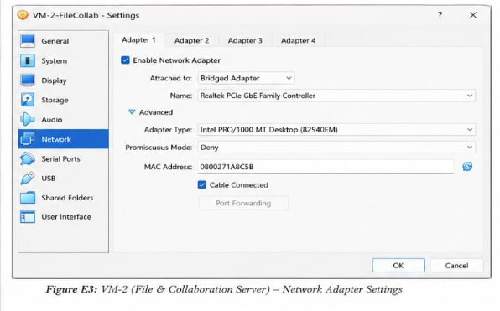

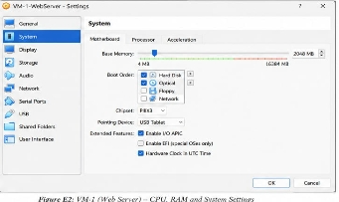

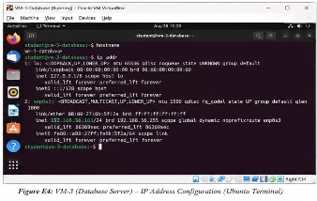
VM deployment evidence note: the network dashboard above shows the logical VM/service topology. For full E1–E4 rubric compliance, insert actual VirtualBox/VMware screenshots showing all four VMs, VM CPU/RAM/storage settings, network adapter configuration, and hostname/IP configuration.

7. Network Configuration and Service Communication

7.1 Connectivity Design
The internal virtual network provides a private communication path between service VMs. The application server uses the database server for persistent data, while users access application and collaboration services through authorized interfaces. The monitoring/backup VM can collect logs or receive backup data from the service VMs.

7.2 Validation Tests
Test | Method | Expected Result | Evidence
IP reachability | ping VM IP from another VM | Packets received with acceptable loss | E8
Application reachability | curl/browser to application endpoint | Valid response page/API response | E5
Database connectivity | Application/database client test | Successful authenticated connection | E7
Remote administration | SSH from authorized client | Successful secure login | E9
Port exposure | Firewall/port verification | Only required ports are accessible | E3/E9

7.3 Example Linux Commands for Validation
ip addr
hostnamectl
ping -c 4 192.168.56.13
ss -tulpen
systemctl --type=service --state=running
curl http://192.168.56.11
These commands are validation examples. The report should include the actual command output or screenshots captured from the implemented environment.

8. Cloud Access and Remote Resource Management

8.1 Access Mechanisms
Mechanism | Use | Security Measure
SSH | Remote Linux administration | Key-based authentication, disable unnecessary accounts, firewall restriction
HTTPS | Secure browser access to web services | TLS certificate and secure configuration
VPN (optional) | Private access from external networks | Authenticated encrypted tunnel
Cloud collaboration login | Student/faculty document access | Strong authentication and role-based access

8.2 Remote Management Procedure
- Connect from an authorized client to the approved private/public endpoint.
- Authenticate using the configured secure method.
- Verify the target hostname and account before performing administrative actions.
- Perform only the required management task using least privilege.
- Record important configuration changes and service status.
- Disconnect after completing the task.

9. User Roles, Permissions and Security

9.1 Role Definition
Role | Typical Access | Restrictions
System Administrator | VM management, system configuration, backups | Administrative actions logged and limited to authorized staff
Faculty | Course folders, teaching documents, collaboration | No VM/root administration
Student | Assigned learning resources and shared documents | No access to administrative/system data
IT Support | Monitoring, service status, selected maintenance | No unnecessary access to academic content

9.2 Security Controls
- Apply least-privilege access and avoid sharing administrator credentials.
- Use strong passwords and, where supported, multi-factor authentication.
- Prefer SSH keys for administrative access.
- Restrict firewall ports to required services.
- Separate management traffic from general user traffic when practical.
- Keep operating systems and server packages updated.
- Back up important documents and configuration data.
- Protect backup storage from unauthorized write access.
- Monitor login attempts and important service logs.
- Use HTTPS for web-based services carrying credentials or sensitive academic content.

9.3 Permission Matrix
Resource | Admin | Faculty | Student | IT Support
Application server administration | Full | No | No | Limited
Academic shared files | Full | Read/Write | Read/Write as assigned | Limited
Student-private files | Controlled | As authorized | Owner only | No routine access
Database administration | Full | No | No | Limited
Monitoring dashboard | Full | No | No | Read/limited
Backup repository | Full | No | No | Limited

9.4 Collaboration Service Design
- Shared course folders for each department/subject.
- Faculty-controlled folders for lecture notes, assignments, and announcements.
- Student group folders for project collaboration.
- Version-aware document editing to reduce duplicate copies.
- Communication channels for course or project teams.
- Permission inheritance from course/group folders with exceptions only when required.

10. Comparison, Analysis and Reflection

10.1 Traditional Infrastructure vs Proposed Cloud-Based Virtualized Environment
Factor | Traditional Physical Infrastructure | Proposed Virtualized Cloud Environment
Resource utilization | Often low because servers are dedicated to individual workloads | Higher through VM consolidation and adjustable allocations
Scalability | Requires procurement and installation of new hardware | VM resources can be resized and workloads can be moved/expanded
Accessibility | Often dependent on campus network and physical systems | Remote access can be provided through secure mechanisms
Cost | Higher hardware, power, cooling, and maintenance burden | Better consolidation; cloud/service subscriptions may be added
Security | Institution controls physical infrastructure but must maintain all layers | Shared responsibility; strong identity, network, and configuration controls required
Collaboration | Separate files and manual sharing are common | Centralized cloud collaboration supports sharing and simultaneous editing
Management | Physical maintenance and local access are required | Centralized virtual and remote management
Disaster recovery | May depend on local backups | Virtual backups and cloud storage can improve recovery options
Limitations | Hardware failure and procurement delays | Provider dependence, network dependence, configuration complexity, recurring cost

10.2 Advantages
- Improved resource utilization through server consolidation.
- Flexible allocation of CPU, memory, and storage.
- Centralized management of multiple services.
- Better support for remote learning and collaboration.
- Faster provisioning compared with purchasing and installing physical servers.
- Isolation between services using separate VMs.
- Easier experimentation and learning because VMs can be cloned or reconfigured.
- Potentially lower infrastructure and maintenance costs for a small institution.

10.3 Limitations and Challenges
- The virtualization host can become a single point of failure in a small lab design.
- Network availability becomes critical for remote access and cloud collaboration.
- Incorrect VM sizing can create CPU or memory contention.
- Security is still a shared responsibility; virtualization does not automatically make a system secure.
- Cloud subscriptions and managed services can create recurring expenses.
- Vendor lock-in can occur when institution-wide collaboration depends heavily on one provider.
- Backup and recovery procedures must be tested rather than assumed to work.
- A classroom prototype does not automatically represent production-scale capacity.

10.4 Reflection and Learning Outcomes
The proposed implementation connects cloud-service theory with a practical virtualized infrastructure. CO1 is addressed by identifying institutional requirements and analysing IaaS, PaaS, and SaaS. CO2 is addressed through VM design, resource allocation, virtual networking, and service communication. CO3 is addressed through secure cloud access, remote resource management, roles, permissions, and collaboration. The exercise also highlights the importance of capacity planning, security, evidence-based validation, and documentation.

10.5 Risk and Mitigation Table
Risk | Impact | Mitigation
Host failure | All demo VMs may become unavailable | Back up VM disks/configuration; use recovery plan
Unauthorized access | Academic or system data exposure | Least privilege, MFA where possible, SSH keys, firewall
Network failure | Remote services inaccessible | Network monitoring and local fallback procedures
Storage exhaustion | Services may fail | Capacity monitoring and storage alerts
Misconfiguration | Service outage or security weakness | Document changes and test after each configuration
Data loss | Loss of academic files | Scheduled backups and restore testing

11. Deliverables and Submission Checklist
The assignment document requires six deliverables. The following checklist should be completed before final submission.
No. | Required Deliverable | Status to Complete | Recommended File/Folder
1 | Architecture Design | ✓ Included in report; verify diagram | architecture/
2 | Virtualized Data Center Implementation & Results | Complete after actual deployment | implementation/
3 | Cloud Service Model Analysis | ✓ Included | report/
4 | Screenshots/Evidence of VM Deployment and Configuration | Insert actual screenshots E1–E12 | evidence/
5 | Comparison and Analysis Report | ✓ Included | report/
6 | GitHub Upload | Create repository and push files | GitHub repository

11.1 Recommended GitHub Repository Structure
cloud-virtualized-collaboration-platform/
├── README.md
├── report/
│ └── Cloud_Based_Virtualized_Collaboration_Platform_Assignment.docx
├── architecture/
│ └── cloud_virtualized_architecture.png
├── implementation/
│ ├── vm-configuration.md
│ ├── network-configuration.md
│ └── service-configuration.md
├── evidence/
│ ├── E1-vm-list.png
│ ├── E2-vm-resources.png
│ ├── E3-network.png
│ ├── E4-ip-config.png
│ ├── E5-application.png
│ ├── E6-collaboration.png
│ ├── E7-database.png
│ ├── E8-connectivity.png
│ ├── E9-ssh.png
│ ├── E10-permissions.png
│ ├── E11-collaboration-edit.png
│ └── E12-github.png
└── README.md

11.2 GitHub README – Minimum Contents
- Project title and problem statement.
- Objectives and technologies used.
- Architecture image.
- VM table and network topology.
- Deployment procedure.
- Service and security configuration.
- Testing results.
- Screenshots/evidence.
- Limitations and future improvements.
- Instructions for reproducing the demonstration.

12. Rubric-to-Evidence Traceability Matrix
Rubric | What the Evaluator Looks For | Evidence in This Submission
CO1 – Requirement Analysis | Clear requirements and justified mapping to IaaS/PaaS/SaaS | Chapters 2–3 + service mapping tables
CO1 – Service Model Analysis | Characteristics, benefits, limitations, cost, scalability, accessibility, security | Chapter 4 comparison and analysis
CO2 – Architecture | Clear VMs, services, resources, networking | Chapter 5 architecture diagram + VM/resource tables
CO2 – VM Deployment | Multiple VMs with correct CPU/RAM/storage/network configuration | Chapter 6 + E1/E2/E3 evidence
CO2 – Network/Communication | VM connectivity and service communication | Chapter 7 + E8 and service-test evidence
CO3 – Remote Access | Secure remote access and explanation | Chapter 8 + E9
CO3 – Roles/Security | Defined roles, permissions, security/resource protection | Chapter 9 + E10
CO1/CO2/CO3 – Analysis/Reflection | Comparison, scalability, utilization, accessibility, cost, security, collaboration, challenges, learning | Chapter 10
Deliverables | Architecture, implementation/results, analysis, screenshots, comparison report, GitHub | Chapters 5–11 + repository

13. Implementation Results – To Be Finalized After Deployment
This section is intentionally structured so that the final report can contain verifiable implementation results. Do not claim a test as successful until it has been performed on the actual virtualized environment. Replace the placeholders below with the measured output and screenshots.
Test ID | Actual Result | Pass/Fail | Screenshot
R1 | VMs boot successfully and receive configured resources. | ____ | E1/E2
R2 | All required VMs communicate over the private network. | ____ | E8
R3 | Application service responds to an authorized client. | ____ | E5
R4 | File/collaboration service allows authorized access. | ____ | E6/E11
R5 | Application can reach the database with valid credentials. | ____ | E7
R6 | SSH remote administration works securely. | ____ | E9
R7 | Role-based permissions prevent unauthorized access. | ____ | E10
R8 | Backup/monitoring process operates as configured. | ____ | E4/E12 or relevant evidence

14. Conclusion
The proposed cloud-based virtualized collaboration platform addresses the institution's need for online learning, file sharing, application hosting, secure user access, and academic collaboration. IaaS is used for controlled virtual infrastructure, PaaS is identified for managed application development/deployment, and SaaS is selected for end-user collaboration and productivity. The virtualized data-center architecture consolidates services into separate VMs while providing a controlled network and centralized management.
The design improves resource utilization, scalability, accessibility, and collaboration compared with a collection of isolated physical servers. At the same time, it recognizes security, network dependency, host-failure, backup, cost, and vendor-dependency challenges. Once the actual VMs are deployed and the marked screenshots are inserted, the evidence set will directly support the rubric criteria and the six required deliverables.

Appendix A – Quick Implementation Checklist
- Install hypervisor.
- Create four VMs.
- Configure CPU/RAM/storage.
- Configure NAT + private virtual network.
- Assign hostnames and private IPs.
- Install application/web service.
- Install file/collaboration service.
- Install database service.
- Install monitoring/backup service.
- Configure firewall.
- Configure SSH securely.
- Create users and roles.
- Test VM-to-VM connectivity.
- Test service communication.
- Test remote access.
- Test permissions.
- Capture E1–E12 screenshots.
- Update results table with actual outcomes.
- Create GitHub repository and upload report/evidence.

Appendix B – Final Submission Checklist
- ☐ Student details filled on cover page.
- ☐ Architecture diagram is present.
- ☐ IaaS/PaaS/SaaS requirement mapping is justified.
- ☐ Cloud service-model comparison is complete.
- ☐ VM resource configuration is documented.
- ☐ Network topology and communication tests are documented.
- ☐ Secure remote-access method is documented and evidenced.
- ☐ User roles and permissions are documented and evidenced.
- ☐ Security controls are explained.
- ☐ Actual VM screenshots are inserted.
- ☐ Actual implementation results are entered; no unverified claims remain.
- ☐ Traditional vs cloud/virtualized comparison is complete.
- ☐ Limitations and reflection are included.
- ☐ GitHub repository is created and linked/recorded.

